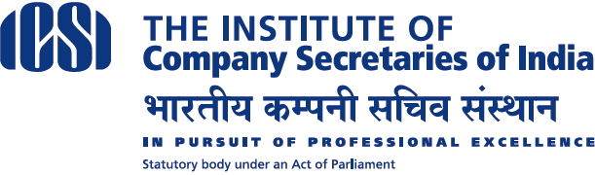
Centre of
Excellence
About ICSI CoE:

The Institute of Company Secretaries of India [ICSI] has come up with its new office named as ICSI Centre of Excellence [CoE] , has been serving the society since Aug, 2017 through various professional development programmes, research and high- end training. CoE is located in IDA Uppal, Hyderabad and is endowed with state of the Art Air-conditioned uplifted Training Hall with facilities viz., customized Tables with Chairs; inbuilt customized LCD with screen; good dais with PA system, recording facility etc. Exclusive Air-conditioned rooms for Office; Director and Meetings and Hostel Block having 25 Air-conditioned rooms for 50 persons accommodation with all requisite facilities i.e. cots with beds; study tables with chairs; cupboards etc., and Exclusive Air-conditioned Dining Hall with Tables and Chairs.

Tentative 15 days 1st Batch Academic Programme at ICSI-CoE for 2019
Sl.  No. | Programme Batch | Schedule * | Fees[Rs.] | Last Date for Registration
1 | 2days Induction programme | 01.2.2019-2.2.2019 | 1500.00 | 29.1.2019
2 | 3 days e-governance | 8.2.2019- 10.2.2019 | 3000.00 | 5.2.2019
3 | 5 days Skill Development | 16.2.2019-20.2.2019 | 4000.00 | 11.2.2019
4 | 5 days Entrepreneurship Development | 27.2.2019 -3.3.2019 | 4000.00 | 25.2.2019

Tentative 15 days 2nd Batch Academic Programme at ICSI-CoE for 2019
Sl.  No. | Programme Batch | Schedule * | Fees[Rs.] | Last Date for Registration
1 | 2days Induction programme | 8.3.2019 – 9.3.2019 | 1500.00 | 5.3.2019
2 | 3 days e-governance | 14.3.2019-16.3.2019 | 3000.00 | 11.3.2019
3 | 5 days Skill Development | 19.3.2019-23.3.2019 | 4000.00 | 16.3.2019
4 | 5 days Entrepreneurship Development | 26.3.2019-30.3.2019 | 4000.00 | 23.3.2019

Eligibility Criteria:
Sl.  No. | Programme Batch | Eligibility and Required Documents
1 | 2days Induction programme | Executive both modules - Passing mark sheets.
2 | 3 days e-governance | 2days Induction Programme Certificate.
3 | 5 days Skill Development | 2days Induction Programme, 3days e Governance Programme Certificates.
4 | 5 days Entrepreneurship Development | 2days Induction Programme, 3days e Governance Programme & 5days Skill Development Programme Certificates.
Venue: Survey No.1, Genpact Road (Near Mallikarjuna Swamy Temple),IDA Uppal,Hyderabad.

Fee to be paid to ICSI Centre of Excellence to the following account details:
Account Name | The ICSI CoE, Hyderabad
Account Number | 293201000002073
Account Type | Saving Account
Name of the Bank | Indian Overseas Bank
IFSC Code | IOBA0002932
Name of the Branch | Street No.8, Habsiguda, Hyderabad
Payment Details to be Forwarded to | coe.hyderabad@icsi.edu

For clarifications please contact us at Tel No: 040-27177722 email: coe.hyderabad@icsi.edu

V S Sarma
Assistant Director
*Schedules are tentative subject to minimum requisite number of registrations.
Hostel Facility available on twin share basis @ 590/- Per Person Per day includes GST 18%

